|  |  |
| --- | --- |
| **Laboratory Activity No. 10** | |
| **The Selection Widgets using Pycharm** | |
| **Course Code:** CPE103 | **Program:** BSCPE |
| **Course Title:** Object-Oriented Programming | **Date Performed:** March 22,2025 |
| **Section:** 1-A | **Date Submitted:** March 22,2025 |
| **Name:** Polestico,Paul Justine D. | **Instructor:** Engr. Maria Rizette Sayo |
| **1. Objective(s):** | |
| This activity aims to familiarize students with the Pycharm framework and selection widget | |
| **2. Intended Learning Outcomes (ILOs):** | |
| The students should be able to:   * 1. To create a Python program that use selection widget like Combobox   2. To use ttk function as part of Tk ( ) in the Tkinter module | |
| **3. Discussion:** | |
| A Graphical User Interface (GUI) application is a program that the user can interact with through graphics (windows, buttons, text fields, checkboxes, images, icons, etc..) such as the Desktop GUI of Windows OS by using a mouse and keyboard unlike with a Command-line program or Terminal program that support keyboard inputs only.  Pycharm is an integrated development environment used for programming in Python. It provides code analysis, a graphical debugger, an integrated unit tester, integration with version control systems, and supports web development with Django. | |
| **4. Materials and Equipment:** | |
| Desktop Computer with Anaconda Python or Pycharm Windows Operating System | |
| **5. Procedure:** | |

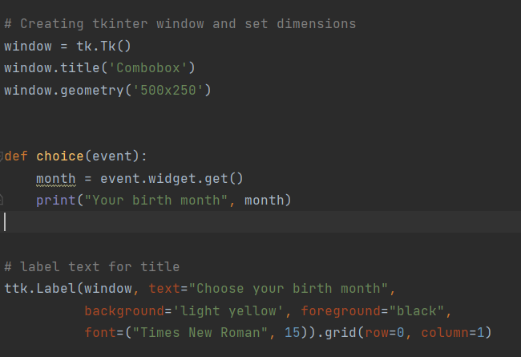

|  |
| --- |
| 1.   1. Run the program and observe the output.   **Adding an icon**   1. Download any .ico picture from <https://icon-icons.com/> or any similar sites. 2. Place the icon in your folder (ex. Oopfa1<lastname>_lab10)     5. Run the program again, the program should now have an icon similar to the program below. |
| **6. Supplementary Activity:** |
| **Task**  1. Create label widgets below to label your birth date <dd>, birth year <yyyy>  2. Create combobox to drop down your birth date <dd>, birth year <yyyy>  3. Create another method to show info about your birth date <dd>, birth year <yyyy>  Note: You may also use additional selection(listbox, radio button, check button) or common widgets to improve the design of your GUI. |
| **Questions**   1. What are selection widgets?   A type of widget where there are values assigned in a single box,usually numbers  Or months. When you click on the box,you can select a value.   1. Which Python libraries provide selection widgets?   One example would be Tkinter,which i used to design the gui of this program. Another  is ipywidgets, which is similar to Tkinter, but used in Jupyter Notebook.  3. How do selection widgets enhance user interaction in GUI applications?  Selection widgets organize predefined values in a single box,which help in organizing your code    while also reducing confusion for the user. |
| **7. Conclusion:** |
| Overall,Selection Widgets are essential in storing multiple predefined values in a single box while also simultaneously separating other predefined values on a different box.  **Please refer to this link:**  [**https://github.com/PaulJustinePolestico/CPE-103-OOP-1-A/tree/main/Laboratory%20Activity%20%2310%20**](https://github.com/PaulJustinePolestico/CPE-103-OOP-1-A/tree/main/Laboratory%20Activity%20%2310%20) |
| **8. Assessment Rubric:** |